
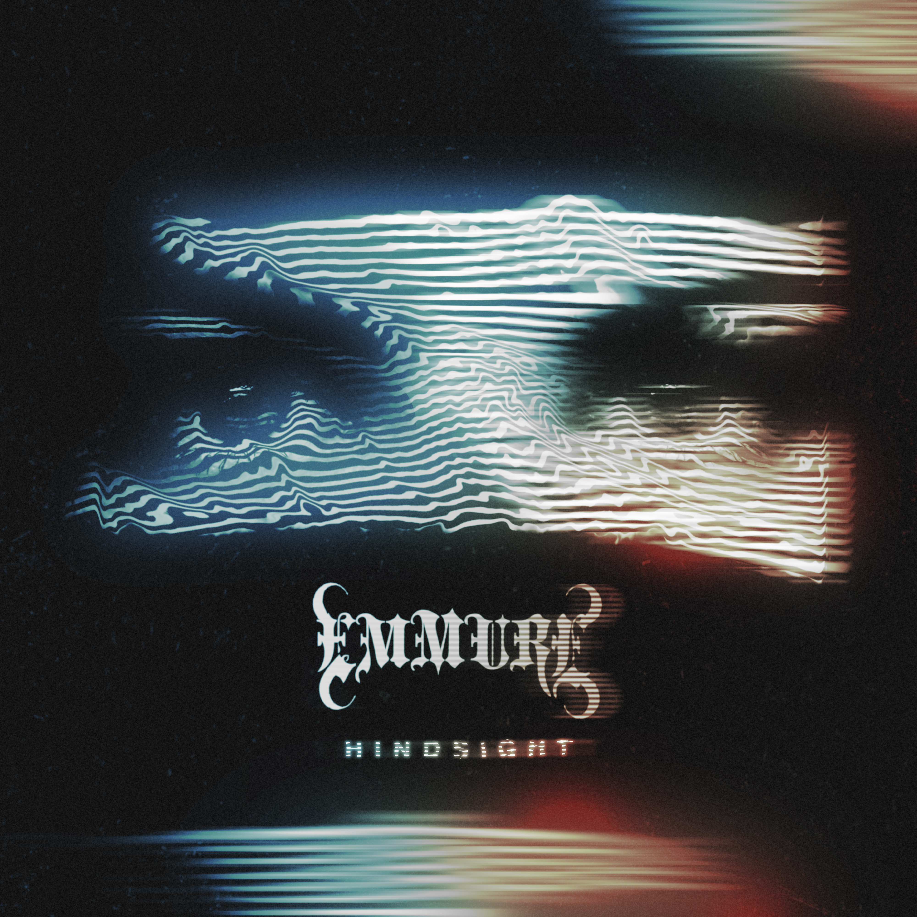

EMMURE
»HINDSIGHT«

OUT: June 26th, 2020

Line up: | EMMURE online:
Frankie Palmeri | Vocals  Joshua Travis | Guitar  Josh Miller | Drums  Nicholas Pyatt | Bass | https://www.facebook.com/emmure  https://www.instagram.com/emmurecult  https://twitter.com/EMMUREmusic  https://www.emmurecult.com/
For a generation of malcontents and outsiders desperate for that extra bit of adrenaline, just to make it through another day, the unrivaled ability of Frankie Palmeri to flip his middle fingers at the world (and himself), with equal bravado and passion, has made EMMURE essential listening.

Heralded as pissed, politically incorrect, and “the most polarizing metal band since Limp Bizkit” in a Revolver Magazine cover story which sought to contextualize internet shit-posts and the band’s “brutish brand of hip-hop-inflected deathcore,” EMMURE lets the music do the talking, first and foremost. Frankie Palmeri doesn’t mince word onstage or off and EMMURE albums are allergic to complicated metaphors and overflowing with unrelenting, unforgiving, unstoppable beatdowns.

“HINDSIGHT” continues the creative partnership between the band’s singer (and sole remaining original member) and whirlwind guitarist Joshua Travis, who injected fresh energy into 2017’s Look at Yourself. It reunites the band with producer WZRD BLD, aka Drew Fulk (Dance Gavin Dance, Motionless In White, Bad Wolves). But where its predecessor viciously fought through suicidal ideation, feelings of hopelessness, and failure, “HINDSIGHT” is somehow more savage and refined.

Bloodthirsty bangers like “Pigs Ear” and “Gypsy Disco” roar with calculated ferocity, as Palmeri examines past decisions, victories, setbacks, and mistakes, with his well-documented knack for fearless autobiographical catharsis. He’s been open about his struggles with substance abuse, ex-band members, and the press. (A few would-be journalists describe him as “combative.”) But it’s exactly that raw authenticity and unrelenting forward motion that makes EMMURE so powerful.

A YouTube video from the Punk Rock MBA channel called “MOST HATED METALCORE BANDS: Emmure, Bring Me The Horizon, Attila” was viewed over 450,000 times in just over six months.

“Gypsy Disco” samples firebrand punk GG Allin, which makes a twisted kind of sense. Palmeri has openly expressed his admiration for the late provocateur, whose exploits were documented in the 1993 documentary, Hated: GG Allin and the Murder Junkies. He’s similarly fond of another controversial and since departed agitator, who fronted the band Anal Cunt. “I would like to have a beer with Seth Putnam or GG Allin,” Frankie told Loudwire. “Those guys were on the level.”

Songs like “Solar Flare Homicide”, “Flag of the Beast”, “Natural Born Killer”, “A Gift A Curse”, “Nemesis”, and “MDMA” became scene anthems thanks to Palmeri’s charisma, a dose of death metal brutality, grooves that inspire both head-nodding and headbanging, and brash aggression.

Since 2003, the Queens, New York born rabble-rouser built EMMURE from a teenaged idea into a nearly two-decade strong extreme music institution, surviving trends, shake-ups, and critics. EMMURE doesn’t play at being “dark” or “angry” for its own sake; Palmeri has always been the same guy both onstage and off. He won’t write the same things he’s already talked about, or phrase things in quite the same way. There are no apologies and no regrets, as each EMMURE album was an honest document of how he felt. And he’s just as outspoken about his growth.

EMMURE’s confrontational spirit and irresistible hooks won them fans on Rockstar Mayhem, Warped Tour, Knotfest, countless festivals, and on tour with a diverse range of bands that includes Five Finger Death Punch, Killswitch Engage, As I Lay Dying, and co-headliners Whitechapel. Across eight albums - like the genre classics “Speaker of the Dead” (2011), and “Eternal Enemies” (2014) – EMMURE battled their way into the extreme music scene like uninvited but necessary guests.

The band’s moniker references “immurement,” a particularly brutal form of execution where a person was trapped behind walls and simply left to die. EMMURE has defied all death sentences, however, from without and within. And while they’ve never been one to court awards or accolades, the fact that heavy metal tastemaker Loudwire put them alongside iconoclastic troublemakers GG Allin and Marilyn Manson in a list of 10 Bands That Didn’t Care If You Hated Them, just before the release of Hindsight, was exactly the kind of press to earn Frankie’s retweet.

“The band’s latest single, ‘Gypsy Disco,’ dropped earlier this year, and listening to it,” they wrote, “it’s safe to say EMMURE still couldn’t give a shit what you think about them.”

Tenacious, raw, and uncompromising in a sea of fakery, EMMURE proudly stands apart.

